**Sharique Zubair**

**(B.Tech. Mechanical Engineering)**

Contact No.: - **7017299199 (**Skype**)**

E-mail: - [shariquezubair01@gmail.com](mailto:shariquezubair01@gmail.com)

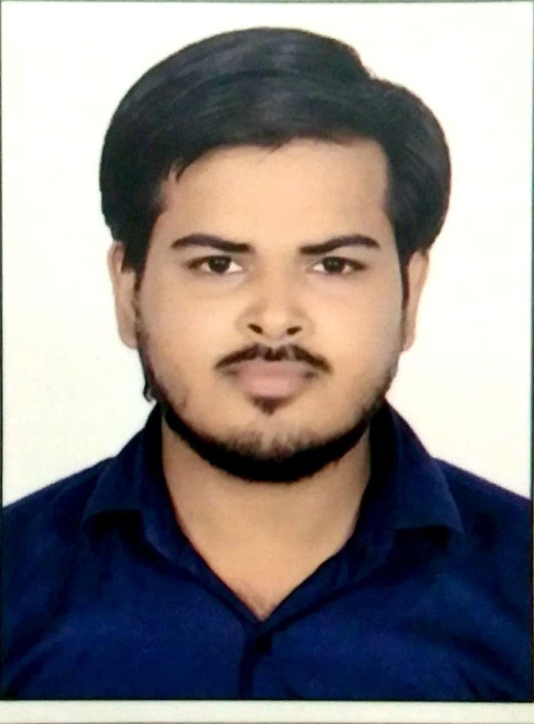

**Present Address:**

1st floor B-2

Al Madina Apartment

New Sir Syed Nagar Aligarh (u.p)

**CAREER OBJECTIVE**

To work in a firm with a professional work driven environment where I can utilize and apply my knowledge. Aspiring challenging assignments in the domain of Mechanical Engineering with an organization of high repute.

B**ASIC ACADEMIC CREDENTIALS**

|  |  |  |  |
| --- | --- | --- | --- |
| **Qualification** | **Board/University** | **Year** | **Percentage (%)** |
| CAD/CAM CATIA | CRICP Bhopal | 2018 | Pass |
| NDT (Level-II)  (UT,MT,VT,PT,RT) | CTES(New Delhi)  ASNT | 2018 | Pass |
| B.tech  (Mechanical) | people's university (Bhopal) | 2018 | 76.28 |
| Diploma  (Mechanical) | HSBTE (Haryana) | 2014 | 64.00 |
| High School | Al Barkaat Public School (CBSE) | 2011 | 66.00 |

**TOTAL WORK EXPERIENCE** 2 Years Full Experience as a Piping supervisor and Assistant design engineer and site execution field.

**PROFESSIONAL EXPERIENCE**

**1. Worked with “Simplex Infrastructures limited” from 04th Sep 2018 to 29 Aug 2019.**

* Supervisor, monitoring and coordinating of all piping activity including planning
* Supervision of piping.
* Preparing Weekly Progress Report & Submit to Project Manager.
* To ensure that the works are carried out according to the Contract Specifications and the approved shop Drawings.
* To ensure that the progressing of works is carried out according to the planned program and as per the approved method Statement.
* Generally looking after quality of work being performed on my site.
* Maintain daily record, Documents & work status related as per drawing.
* Data entry of manpower, material & equipment on Excel.
* Preparation of general arrangement drawing and piping ISOMETRIC from GAD and equipment layout.

**2. Worked with “SHILPI ENGINEERRING PVT.LTD” from 02nd Sep 2014 to 30 July 2015.**

* Supervisor, monitoring and coordinating of all piping activity including planning.
* Compressed air piping checking installation and testing.
* Planning the activities within time limits, Cost control by effective use of material and Man-power.
* Worked on Boiler, Economizer, Air preheater, furnace, electrostatic precipitator.
* Ensure that all safety practices and procedures for safe working are fully implemented.
* Hot oil piping system checking installation and testing.

**EXPERIENTIAL LEARNING (SUMMER INTERNSHIP PROGRAM)**

* + - **Company Name :-**  **U.P Rajya Vidyut Utpadan Nigam LTD (power plant)**
    - **Project Title :- Coal Handling, Boiler Maintenance division, Turbine System**
* **Duration :-** 30 days (02th July 2013 to 29th July 2013)
  + - **Company Name :- Mechanical workshop N.E Railway**
    - **Project Title :- Machine process, welding process, tools**
    - **Duration :-** 30 days (03rd July 2017 to 01st Aug 2017

**PROJECT REPORT**

* **Hydraulic Press.**

Press handling for washer

* **Highway wind energy.**

Highway dividers calculation, Piping and light focus

**TECHNICAL SKILLS**

* Preparation of drawing and piping ISOMETRIC from GAD and equipment layout.
* Supervisor, monitoring and coordinating of all piping activity including planning.
* Reading and editing of piping drawing.
* Ventilation System design.
* Preparation of Piping, Design Drawing.

**PERSONAL STRENGTHS**

* Hard working and goal - oriented.
* Passionate and sincere.
* Good communication skills and quick learner.
* Effective team player with a systematic approach and quick adaptability.
* Providing Drawing and Information to Contractors and Site Personnel.
* Site Co-Ordination with other services.

**IT PROFICIENCY**

* Auto CAD
* Knowledge about computer hardware
* Microsoft Office Word, Microsoft Office Excel, Microsoft Office Power Point
* Internet Browsing

**ACHIEVEMENTS**

* Award for Academic Excellence in year 2010.
* Participated & Training in LIGHT: Enlightening the Life, MAINT Energy centre Bhopal.
* Participated in the International conference on EMERGING TRENDS IN TECHNOLOGY AND SCIENCE.
* Served as captain cricket in al-Barkaat.
* Served as students coordinator training and placement cell TERII.
* Organized and participated in "workshop 2014" by mechanical department..

**PERSONAL DETAILS**

* **Fathers Name :- Mr. Khursheed Anwar Najmi**
* **Date of Birth :-** 13th January 1994
* **Language Known :-** English, Hindi & Urdu
* **Marital Status :-** Single
* **Nationality/Religion :-** Indian / Islam

**PASSPORT DETAILS**

* **Passport No. :-** S9145107
* **Date of Issue :-** 06/12/2018
* **Date of expire :-** 05/12/2028
* **Place of Issue :-** Ghaziabad, India

**DECLARATION**

I do hereby declare that the above information is true to the best of my knowledge**.**

**Place: Sharique Zubair (Signature)**