Observations 19 September 2020
- Tab to be made like other tabs present in black colour in the left-hand side menu.
All Categories, List of Products, List of Companies.
(Remove the blue colour) and convert just like the other options present.

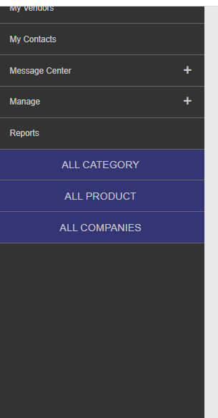

- My Account and My Company to be added to the left-hand side menu. It can remain under the picture also.

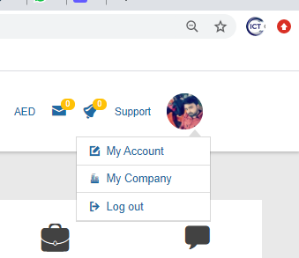

- Remove the extra buttons from the bottom box.
Product Portal, Discussion, and downloads Contact support team, Your Company, Message Center.

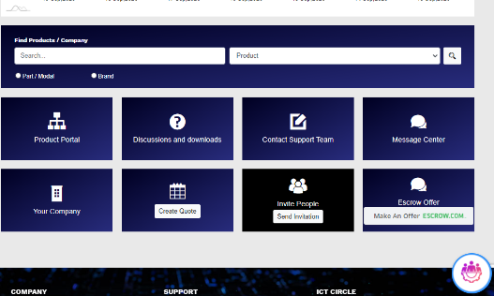

- Organize the rest 3 buttons Escrow Offer, Invite, Create Quote.

- Have to work on the RFQs layout.

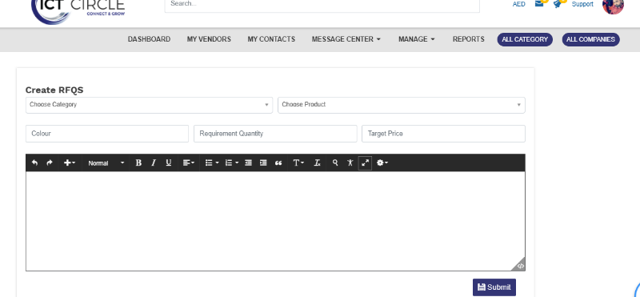

- Move the product search bar up. That it should be visible when you login and dashboard appear.

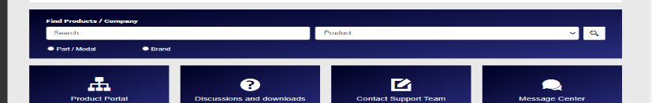
- When login is done after logging out, notification is showed on the right upper corner. But nothing appears in the admin updates or notification bar.

